UAE PDPL Compliance for Log360
Strengthen data protection and meet UAE PDPL compliance with Log360.
Region: UAE | Type: Data Privacy, Government/Public Sector | Category: Compliance | Pricing: Free

Overview
The UAE PDPL compliance extension in Log360 helps organizations meet UAE Federal Decree-Law No. 45 of 2021 on Personal Data Protection, the UAE's first federal data protection law applying to all entities processing UAE residents' personal data by providing centralized log management, real-time breach detection, and audit trail generation. The platform supports UAE PDPL requirements for data security controls, breach notification, access control, identity verification, controller accountability, cross-border transfer monitoring, data subject rights tracking, and compliance audit records.
For Personal Data Processing Principles, Log360 generates comprehensive audit trails of data access and system events to demonstrate lawful, purpose-limited processing and evidence the accountability obligations of Article 5. To address Security of Personal Data, the platform provides network security monitoring, threat detection, and user access reports to implement and evidence the technical safeguards required by Article 20. The extension also supports Data Breach Detection and Notification by providing capabilities that Log360's real-time threat detection, anomaly alerts, and failed access reports minimize detection time and provide forensic timelines for Article 9 notification.

Key Features
- Access Control and Data Subject Rights: Log360 provides user activity audit logs and file access reports to support data subject rights fulfilment and evidence controller access governance practices.
- Identity Verification and Authentication Controls: Log360 monitors MFA authentication events, AD logon activity, password auditing, and account changes to evidence access is restricted to authorized, identified parties.
- Controller and Processor Accountability: Log360 provides GPO auditing, user management logs, and system event reports as the technical accountability evidence layer.
- Cross-Border Data Transfer Monitoring: Log360 monitors AWS network activity, cloud storage transfers, and S3 file operations to detect unauthorized cross-border data flows and evidence transfer governance.


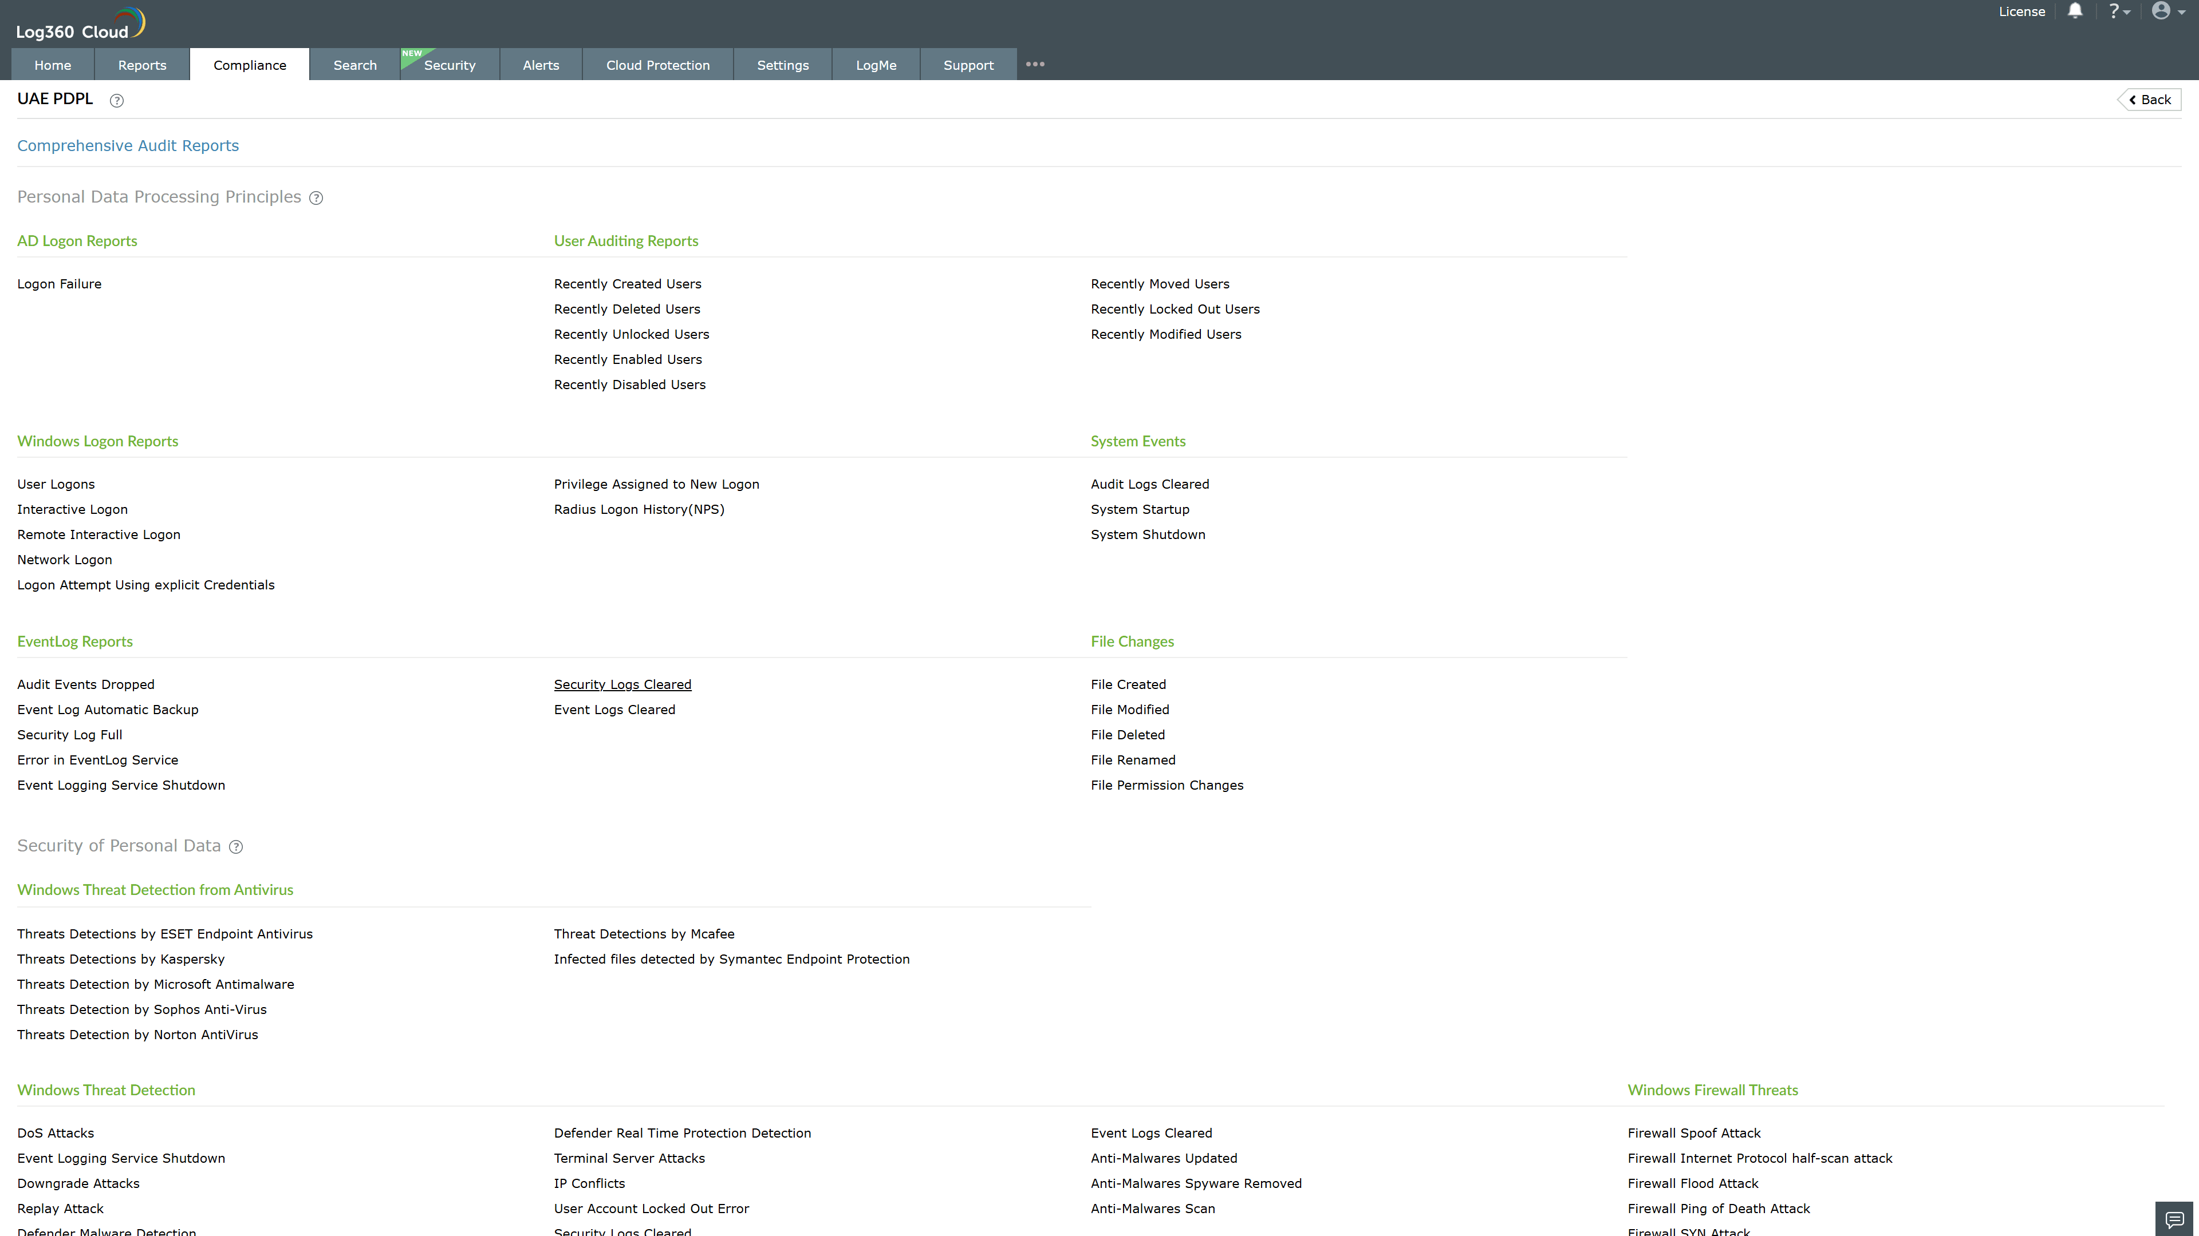
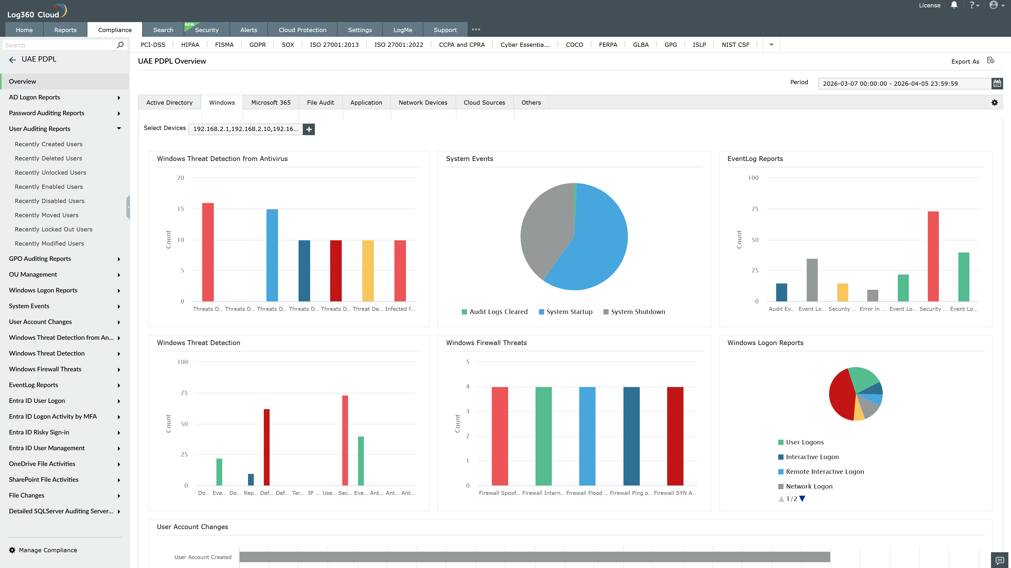
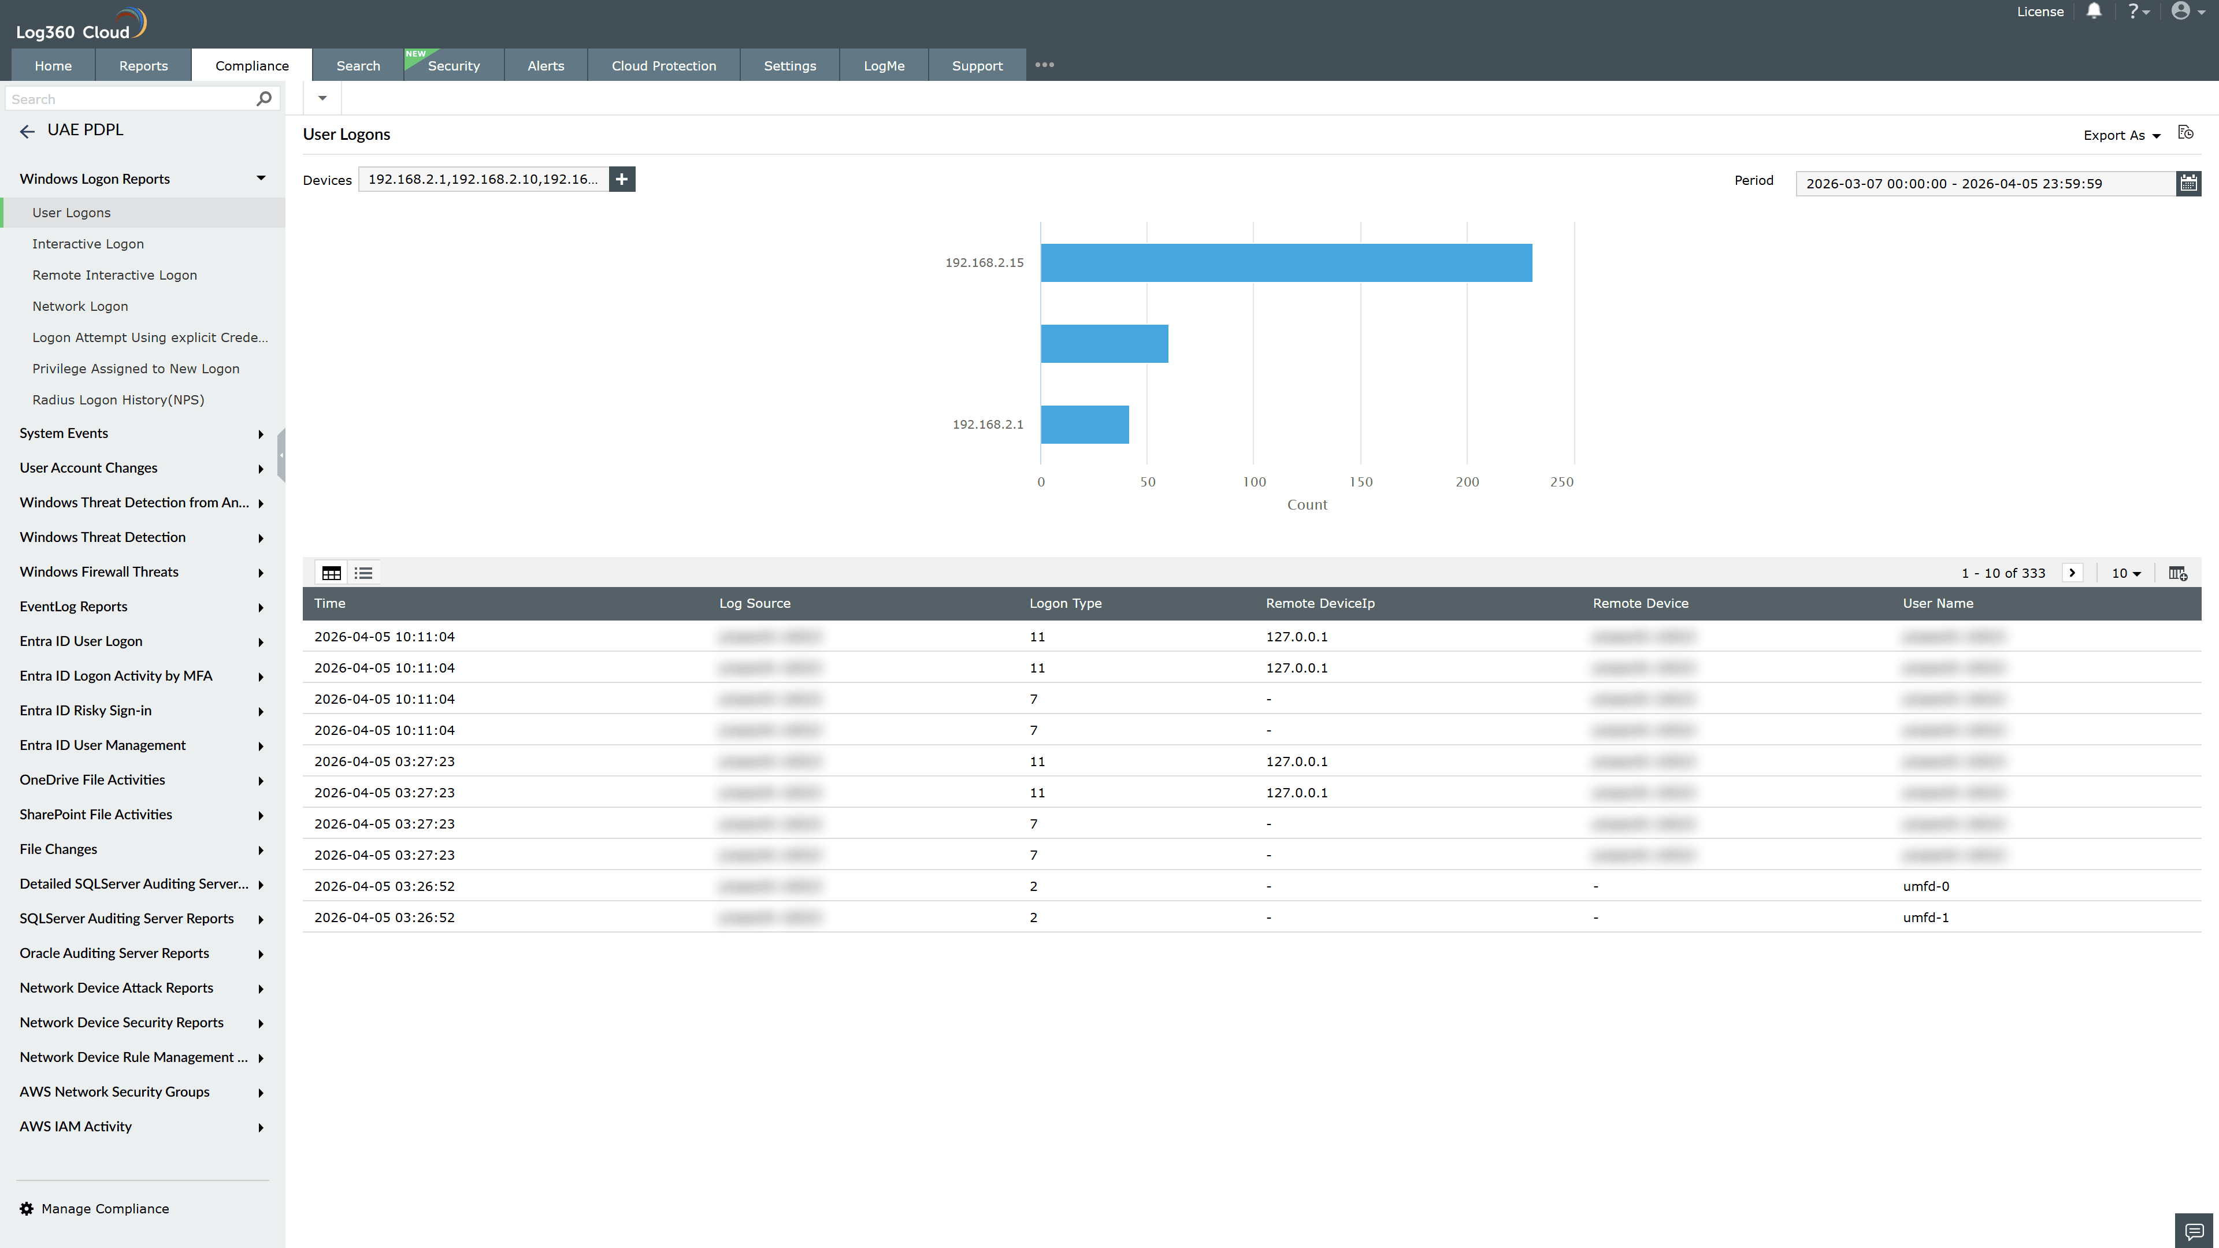
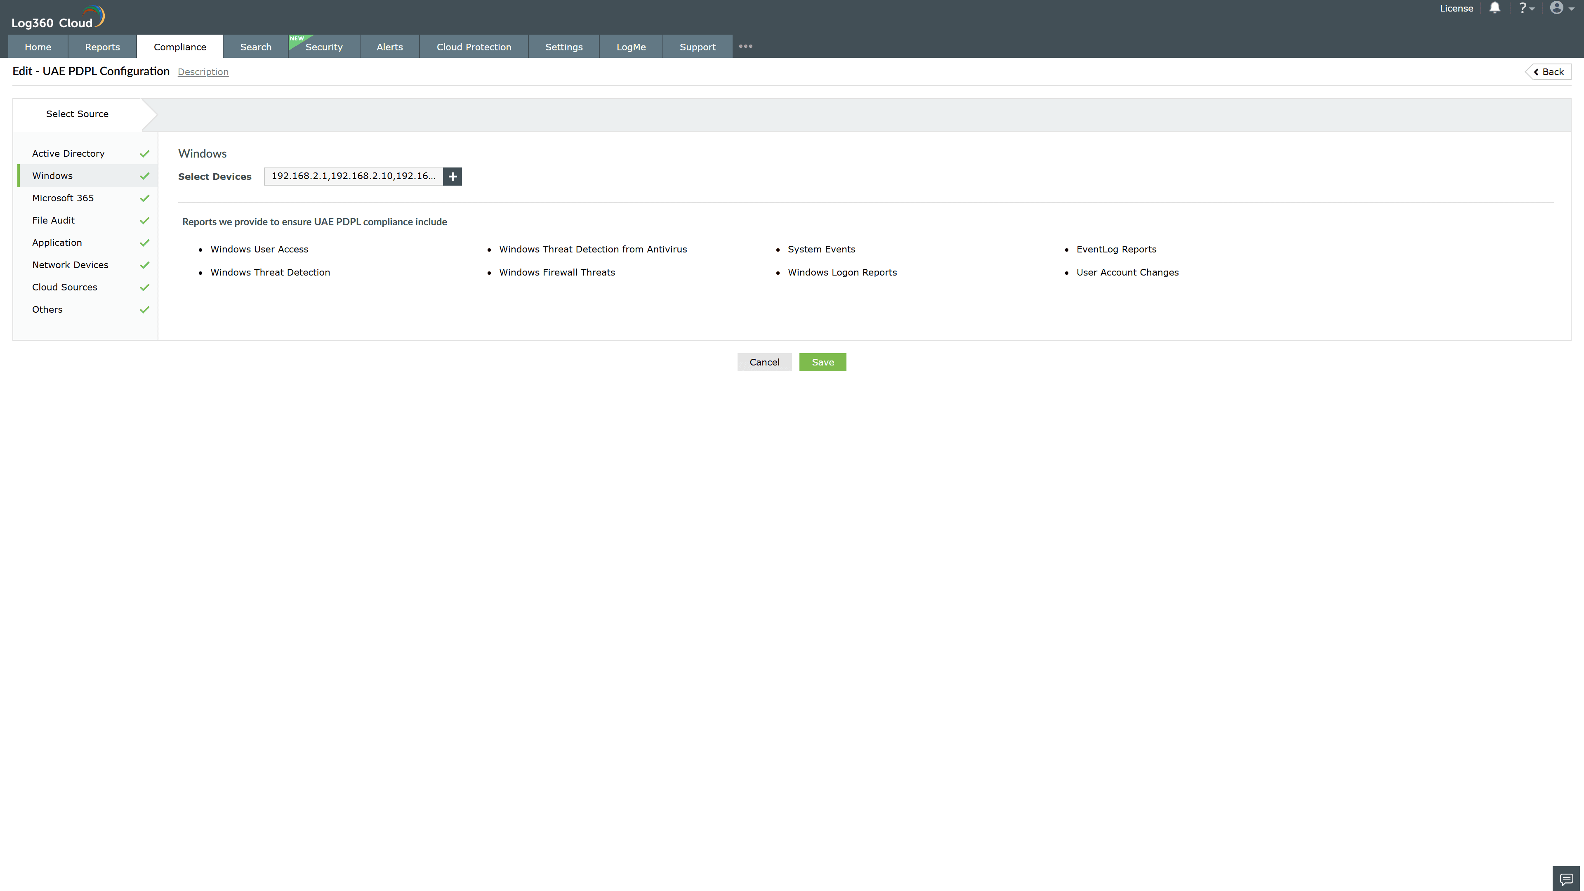
Valid Submission : Yes
Supported Editions : Free, Basic, Standard, Professional, MSSP
Help Document : https://www.manageengine.com/log-management/help/integrations/compliance-extensions.html
Help Video : Not provided
Tags : Log360, Compliance, Privacy monitoring, Data privacy, Regulatory compliance
Supported DCs : US, IN, JP, CA, AU, UK and EU
Privacy Policy:
Terms of Service:
Release Notes:
Predefined reports for the UAE PDPL.

